1)We have used primary key below

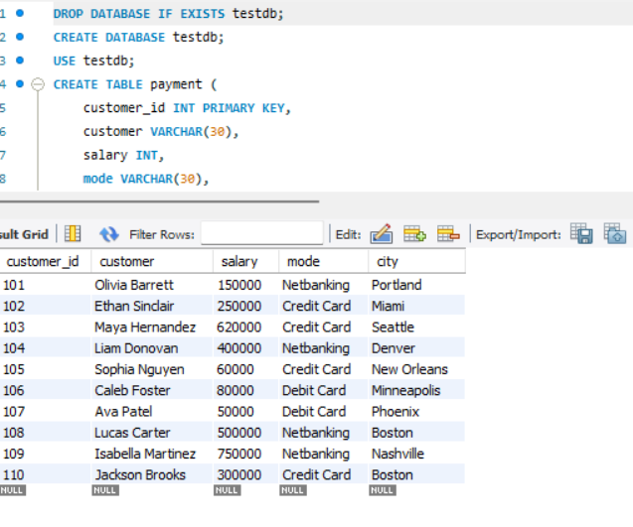

2)We have used foreign key below

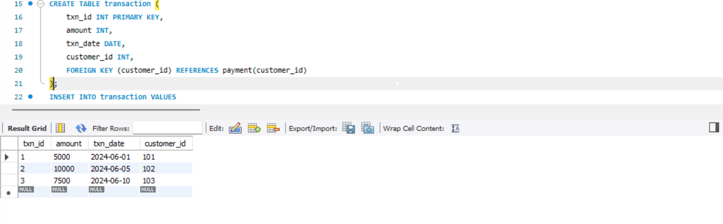

3)We have used update,delete Cascade operators below

